INTRODUCTION TO

COMPUTER NETWORK

Lab-01

Computer Networks COSC-3201
Lab Instructor:

Sir Inzimam Shahid

Student Name | Muhammad Saad Ali
Student Roll # | DSAI241103089
Department | BSAI
Year/Section | 3B

Lab 1: Introduction to Computer Networks

Objective:
The purpose of this lab is to introduce students to basic network concepts, network devices, and essential commands used to verify and test connectivity in a computer network.

Introduction:
Computer networks allow multiple computers and devices to communicate with each other for the purpose of data sharing, resource sharing, and communication. A network can consist of a few devices or thousands of interconnected systems across different locations. Understanding how devices communicate is fundamental for learning advanced networking concepts.

Network Devices Overview:

- Router:
A router is responsible for forwarding data between different networks. It chooses the best path for data based on routing tables and protocols.

- Switch:
A switch operates within a local network. It connects multiple devices and forwards data based on MAC addresses.

- Hub:
A hub is a simple device that broadcasts incoming data to all connected devices. It does not use any addressing and is considered less efficient than switches.

- Network Interface Card (NIC):
A NIC allows a computer to connect to a network. It can be wired or wireless and provides the hardware address required for communication.

Basic Network Commands:
Students will learn and practice the following commands:

- ipconfig / ifconfig:
Used to view IP address, subnet mask, and network interface information on Windows or Linux systems.

- ping:
Used to test connectivity between two devices. It sends ICMP packets to check if a host is reachable.

- tracert / traceroute:
Displays the path packets take from the source to the destination. It helps identify delays or failures in a network.

Lab Activities:
1.Identify and classify real or virtual network devices (router, switch, hub, NIC).

. Router
Type: Real & Virtual device
Function:
- Connects multiple networks (like your home network to the internet).
- Routes (forwards) data between networks based on IP addresses.
- Uses routing tables and protocols to decide the best path for data.
Examples:
- 🖥 Real Router: TP-Link, Cisco, Huawei router.
- 💻 Virtual Router: Software routers like Cisco Packet Tracer Router, GNS3 virtual router, or pfSense.
Category: Layer 3 device (Network Layer)

2. Switch
Type: Real & Virtual device
Function:
- Connects multiple computers or devices within the same local network (LAN).
- Forwards data based on MAC addresses.
- Reduces network traffic and increases efficiency compared to a hub.
Examples:
- 🖥 Real Switch: Cisco Catalyst, Netgear Switch.
- 💻 Virtual Switch: VMware vSwitch, VirtualBox Host-Only Adapter, or Cisco Packet Tracer Switch.
Category: Layer 2 device (Data Link Layer)

3. Hub
Type: Real device (rarely used today), limited virtual support
Function:
- Connects multiple devices in a network but broadcasts data to all ports, causing more collisions.
- Does not filter or manage traffic.
- Used mostly for simple or educational purposes.
Examples:
- 🖥 Real Hub: D-Link Ethernet Hub, Netgear Hub.
- 💻 Virtual Hub: Simulated in software like Cisco Packet Tracer.
Category: Layer 1 device (Physical Layer)

4. Network Interface Card (NIC)
Type: Real & Virtual device
Function:
- Allows a computer or device to connect to a network (wired or wireless).
- Each NIC has a unique MAC address for identification.
- Can be physical (installed in computer hardware) or virtual (for VMs).
Examples:
- 🖥 Real NIC: Intel Ethernet Adapter, Wi-Fi card in laptop.
- 💻 Virtual NIC: VMware Network Adapter, VirtualBox Adapter, Hyper-V Virtual NIC.
Category: Layer 2 device (Data Link Layer)

2.Use the **ipconfig/ifconfig** command to find the IP address of your system.

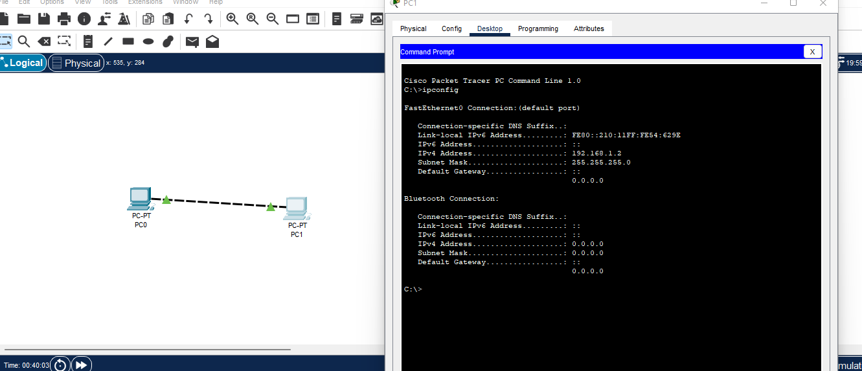

3.Perform connectivity tests using the **ping** command to different IP addresses (local and external).

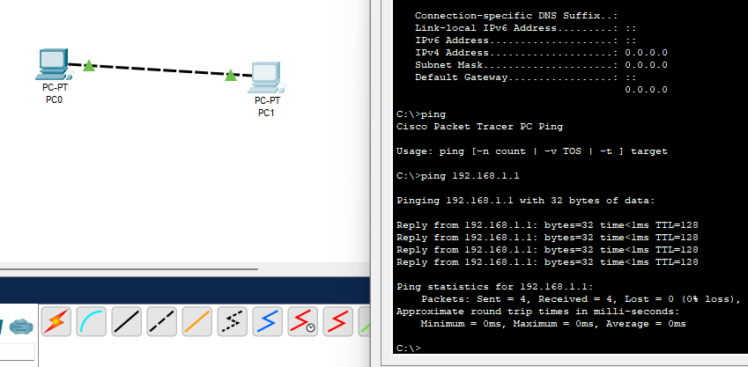

4.Use the **tracert/traceroute** command to observe the path taken by packets.

